|  |  |  |
| --- | --- | --- |
| NAME | REGISTRATION NO. | ROLL NO. |
| BIKIRAN BORAH | 12111199 | RK21WYA26 |
| VISHAL KUMAR SINGH | 12104228 | RK21WYA01 |



SUBMITTED BY :-

PROJECT:-Design a System for booking Cabs within LPU using python.

PRE SUBMISSION REPORT

FOR PYTHON GROUP PROJECT.

COURSE CODE :- INT 213

**Introduction :**

Online Cab Booking System specializing in Hiring cabs to customers. It is an online system through which customers can view available cabs; register the cabs, view profile and book cabs.Cab booking service is a major transport service provided by the various transport operators in a particular city. Mostly peoples use cab service for their daily transportations need. The company must be a registered and fulfils all the requirements and security standards set by the transport department. Online Cab Booking System is a web based platform that allows your customers to book their taxi's and executive taxis all online from the comfort of their own home or office. The platform should offer an administration interface where the taxi company can manage the content, and access all bookings and customer information. More and more Taxi companies are looking for integrated taxi booking systems as it makes life much easier for (1) The traveler - this is highly important and in today's internet age people should be able to book taxis online without having to pick up the phone and (2) the taxi company as all their bookings are now managed via an automated system which means they have an electronic record of future and historic bookings A Cab Booking/Hiring is a system that can be used temporarily for a period of time with a fee. Hiring a car assists people to get around even when they do not have access to their own personal vehicle or don't own a vehicle at all. The individual who want to hire/rent a car must first contact the cab hiring company for the desire vehicle. This can be done online. At this point, this person has to supply some information such as: dates of rental, and type of car. After these details are worked out, the individual renting the car must present a valid Identification Card. Most companies throughout the industry make a profit based of the type of cars.

**Roles Of Members:-**

Bikiran Borah: - Coding, Managing project, Testing, GUI, Presentation

Vishal Kumar Singh: - Coding, Collecting Resources, Public Speaker, GUI

**TIMELINE:** -

Module 1:-Till 30th September Pre submissions report.

Module 2:-Till 10th October Collecting Resources and PowerPoint presentation should be ready.

Module 3:-Till 3rd November complete preparation of project requirement and specification and testing.

Submission:-Till 4th November.

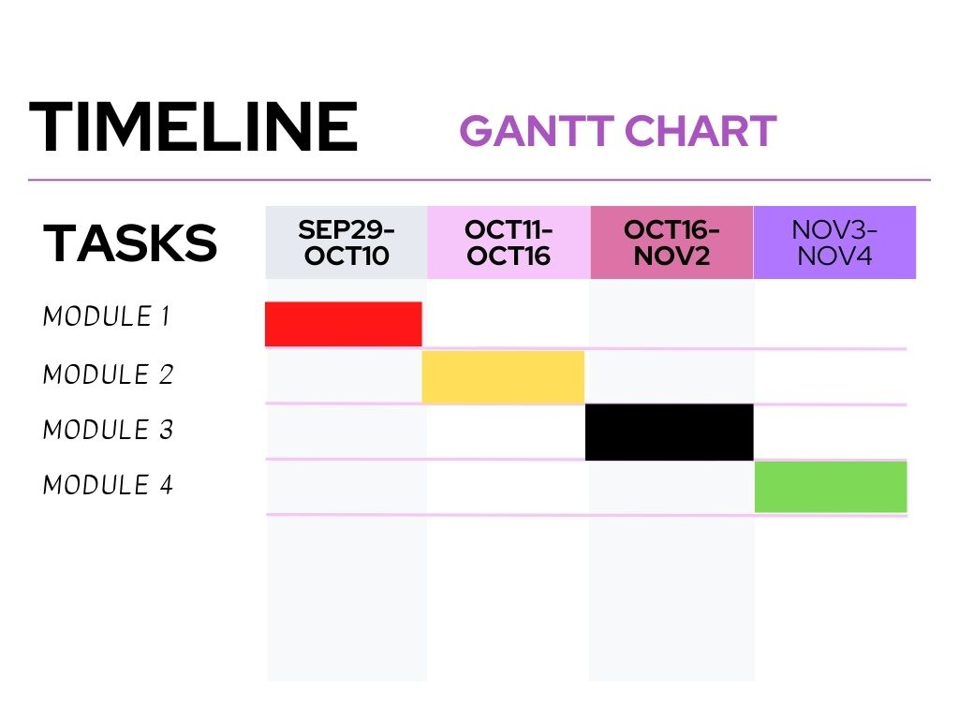

***SUBMISSION***

**DFD FOR THE PROJECT:-**

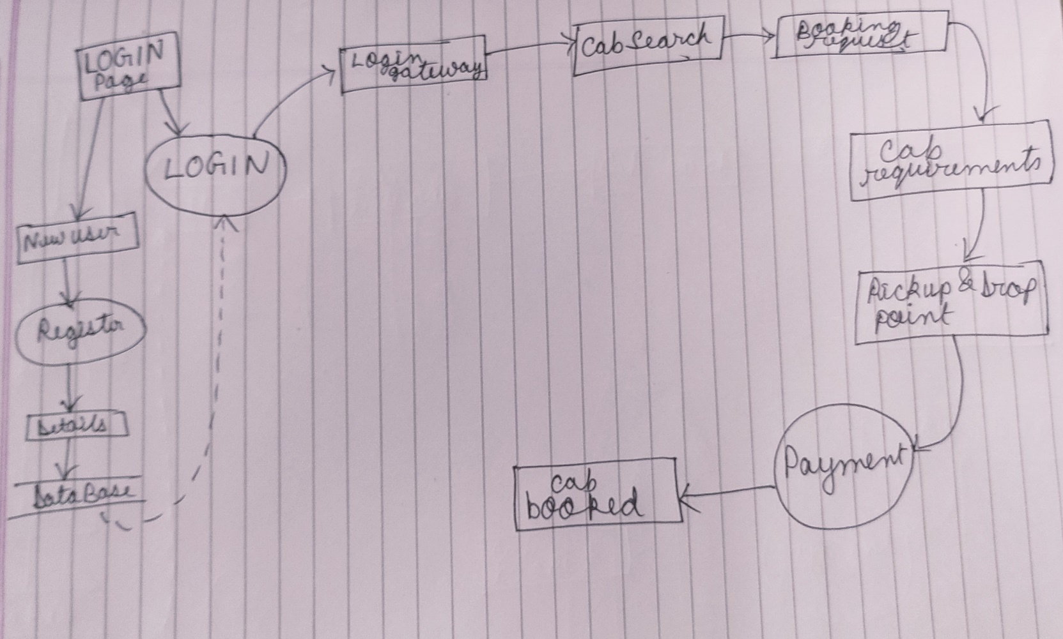

**Bibliography : --**

Google:- collecting resources

Stackflow : - Got support in coding

Microsoft Excel :- Help in making of Gantt Chart

Microsoft Word :- Pre-report is done on Word

Microsoft PowerPoint presentation : -- Help in making of PPT’s for presentation purpose.